CSC8360 S2 2022 PRACTICE 4 [Comments]

**Wireless LAN (WLAN)** Due Date: xx/xx/2022

**Practice Question #1:**

Search the internet, locate and review the various standard for Wi-Fi (IEEE 802.11).  List the wireless network speed improvements and the associated IEEE 802.11 standard that helped deliver that improvement.

ANSWER:

*Go to* [*IEEE 802.11*](https://www.ieee802.org/11/index.shtml)

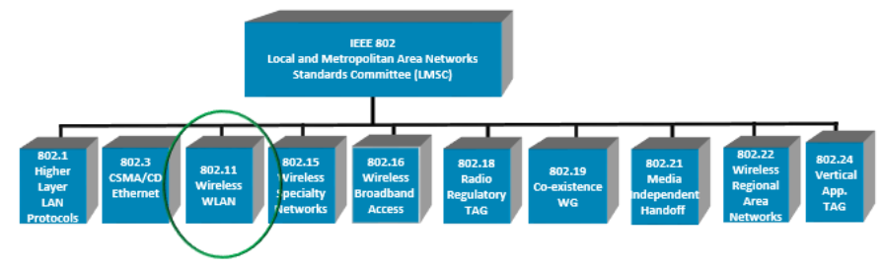]

**Practice Question #2:**

List and describe the most commonly deployed Wireless LAN Topologies.

ANSWER:

*WLANs can be built with either of the following topologies:*

* *Peer-to-peer (ad-hoc) topology*
  + *Access point communicate to each other directly and each device is a client (ie. no fixed topology - adhoc).*
  + *Wireless devices connect to each other without using a centralized device such as a Wi-Fi router or access point*
* *Access point based topology*
  + *Wireless devices transmit and receive data via wireless (WiFi access point) and wired networks (eg; router).*
* *Point-to-multipoint bridge topology*

**Practice Question #3:**

List and describe the various modes of Wireless LANs.

ANSWER:

*There are two modes defined in IEEE 802.11 WLAN standard, namely: adhoc mode and infrastructure mode.*

*In adhoc mode, WLAN wireless network is composed of only stations (802.11 compliant NICs). There will not be any access point in the network. The networked systems (ie: wireless devices communicate directly with one another). This mode is also referred as IBSS (Independent Basic Service Set) or peer to peer mode. Adhoc mode allows for wireless connectivity to be quickly established.*

*In infrastructure mode, wlan network is consists of both wireless devices and access points (APs). All the communications between wireless devices connected to the WLAN will go through an Access Point (ie; acts as a router).*

*A WLAN with one AP is referred as BSS (Basic Service Set) and a WLAN with more than one APs is referred as ESS(Extended Service Set).*

**Practice Question #4:**

Describe the criteria which a local area, wide area and global wireless LAN would be each be considered for deployment. [Needs to be more specific]

ANSWER:

[Needs to be more specific]

* *Develop prac to expand knowledge of WLAN*
  + *Include diagrams/scenarios*
  + *Topologies*
    - *Hub-Spoke*
    - *Mesh/Semi-Mesh (Resilient)*
    - *Policy Based / Preference Connection (based upon B/W, latency, Channel)*
    - *Channel Allocation (Fixed vs Dynamic)*
    - *SSID (Main vs Guest)*
      * *MININET*
    - *Security Concerns*
    - *Wireless relay (booster, extended range)*
    - *WiFi Range (When is a booster needed)*
    - Wifi Sniffer Application
  + *Provide Answers*

**Practice Question #5**

Please include a question about *distances* which gives some guidance / experience concerning how big a region an access point can cover.

Please also include some consideration of interfering structures, such as walls, internal and/or external.